Quiz Review!
Earth’s Layers:
You will need to know the 4 layers, what the are made of (solid, liquid, what metal etc) and one other fact (temperature, depth). Use the diagram below and add facts from your notes.
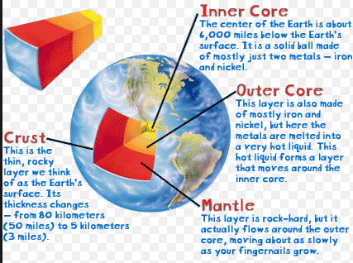

Crust | Mantle | Outer Core | Inner Core

Rock Cycle:
You will need to know how each rock type can be transformed, and the name of the process. You will also need to know characteristics of rock’s appearances and 2 examples of each! Again, use the rock cycle below to help and add in from your notes.
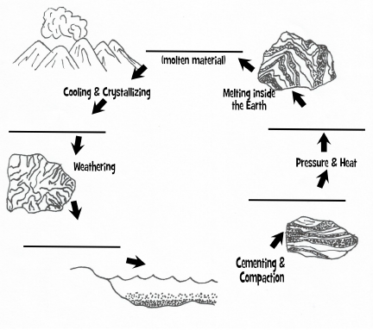
Type of Rock | How it is formed (which process) | Appearance | 2 examples

